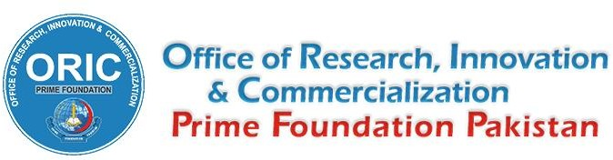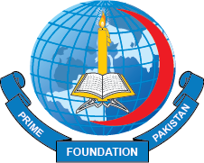

POLICY FOR PUBLICATION INCENTIVES

The Office of Research, Innovation and Commercialization is working towards promoting research culture and motivating faculty, staff, and students of Prime Foundation (and its allied institutes) to publish their original work in recognized journals inside and outside Pakistan.

- To receive publication incentive, the applicant must be:
  - A faculty member, staff, or student of Prime Foundation and its allied institutes at the time of the study / publication;
  - This affiliation must be mentioned in the published paper along with the name of Riphah International University, e.g., Department of , Peshawar Medical College/ Peshawar Dental College/ Rufaidah Nursing College/ Prime Institute of Public Health/ Prime Institute of Allied Health Sciences, Riphah International University, Islamabad – Pakistan.

- The proposal of the paper must be approved by the IRB of Prime Foundation.

- For a multicenter study published in an HEC recognized journal, where affiliation is not mentioned as advised in point 1b of this document, the office of research will decide on case-to- case basis. In such a study, the permission should be taken from the IRB of Prime Foundation, in lieu of point 2 of this document, which will be issued on case-to-case basis.

- A pre-defined amount of incentive will be awarded to those eligible, upon application.

- The role and contribution of an author will be assessed by the research incentive committee that will also take into consideration the role as a corresponding author or single/ multiple authors from Prime Foundation in a multicentered study.

- The amount of incentive will be calculated on the research incentive calculator, based upon authorship position and category of publication.

- Categories of publication for papers in health and allied sciences are based on the impact factor of the journal issued by Clarivate. However, the journal must be listed in the HEC Journal Recognition System of Higher Education Commission, Pakistan (https://hjrs.hec.gov.pk). The categories are as follows:
Category Number | Description | Max. Incentive in PKR
1 | Impact Factor > 5 | 300000
2 | Impact Factor 3 to 5 | 200000
3 | Impact Factor 2 to 2.99 | 150000
4 | Impact Factor 1 to 1.99 | 100000
5 | Impact Factor < 1 | 50000

- Papers published in HEC recognized journals that are not in line with the health and allied sciences (e.g., Islamic Studies, Library Science and related Social Sciences etc.), will be dealt by the research incentive committee and if approved, a maximum of 100000 PKR may be granted as an incentive. The first author may receive a maximum of 100000 PKR, the second author may receive a maximum of 75000 PKR and third author onwards may receive a maximum of 25000 PKR as publication incentive. However, if the paper is published in a journal with an impact factor, point 7 of this document will apply, as mentioned above.

